Creating and editing hotspots for resource bundles
("r" in a blue square hotspots)

Please note that it is essential to test out any edits before overwriting files. I recommend you keep a master copy of all the correct files, and then make a copy of this for editing purposes, only replacing files in the master copy when you are absolutely sure all edits have worked correctly. I also recommend you keep a master copy of all the files as originally delivered by us, so that there is an original to refer back to should something be accidentally altered or erased.

The "maps in time" interactive is comprised of several different flash files.

There are 3 levels of flash file in the interactive.

level 1: "maps-in-time" fla
level 2: "zoom" fla's
level 3: resource bundle pop up box fla's

The top level file is "maps-in-time.fla", and the other files are loaded into this file as needed. Next there are 11 flash files containing the zoomed in maps (eg zoom-1914.fla contains the first map), and finally a set of flash files containing the information for each individual resource bundle pop up window.

As well as the map itself, each "zoom" file also contains the accompanying event info hotspots ("i" in a red circle) and the links to resource bundles ("r" in a blue square).

Editing an "r" hotspot that already exists

There are 2 editable elements in each of these hotspots. You can edit the rollover text, and you can edit the link leading to the associated pop up box.

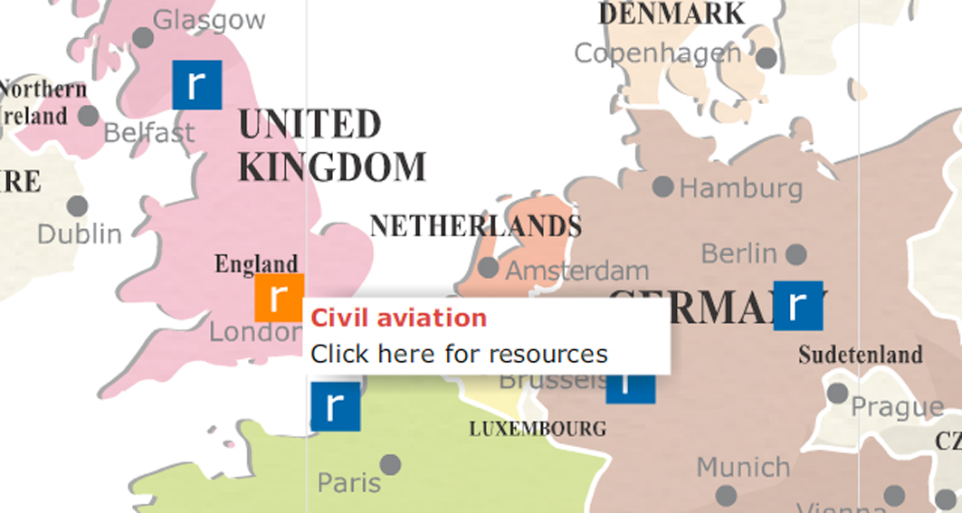

Example:

if you want to edit the hotspot for the "civil aviation" resource bundle on the 1939-1945 map, you will first have to open the file "zoom-1945.fla".

You then need to look inside the library of this file, where you will see a folder called "resource clips". This folder contains all the movie clips for the individual blue square "r" links. I have named all these clips similarly, so that they start with "res" (short for resource) followed by text related to their subject, so in this case, the one you are looking for would be "resAviation".

Double/right click the clip in the library, so that it appears on the stage. The clip contains only 1 element, which is an instance of the resource button. Open the actions palette, then select this button on the stage, so you can see the actions associated with it. The actions will appear as below.

---------------------

on (rollOver) {
_root.infoTextBox.htmlText = "<font color='#CC3333'><b>Civil aviation</b></font><br>Click here for resources";
trace("_root.linkBox.resInfo");
setWidth = _root.zoomBase.mapHolder._width/2799.7;
setHeight = _root.zoomBase.mapHolder._height/1843.2;
_root.infobg._width = _root.infoTextBox._width;
_root.infobg._height = _root.infoTextBox._height;
setBoxX = (((this._x+this._parent._x)-_root.window.x/setWidth)*setWidth);
if (setBoxX+_root.infoTextBox._width>550) {
setBoxX -= _root.infoTextBox._width+this._width*0.75;
} else {
setBoxX += this._width*0.75;
}
_root.infoTextBox._x = setBoxX;
if ((((this._y+this._parent._y)-_root.window.y/setHeight)*setHeight)+_root.infoTextBox._height>400) {
_root.infoTextBox._y = (((this._y+this._parent._y)-_root.window.y/setHeight)*setHeight)-_root.infoTextBox._height;
} else {
_root.infoTextBox._y = (((this._y+this._parent._y)-_root.window.y/setHeight)*setHeight);
}
_root.infobg._x = _root.infoTextBox._x;
_root.infobg._y = _root.infoTextBox._y;
}
on (rollOut, releaseOutside) {;
_root.infoTextBox.htmlText = "x";
_root.infoTextBox._x = -1000;
_root.infoTextBox._y = -1000;
_root.infobg._x = -1000;
_root.infobg._y = -1000;
}

on (release) {
_root.mapKey.tabEnabled = false;
_root.mapKey.tabChildren = false;
_root.zoomBase.tabEnabled = false;
_root.zoomBase.tabChildren = false;
_root.timeline.tabChildren = false;
_root.menuMain2.tabChildren = false;
_root.linkBox._visible = true;
_root.linkBox._x = 0;
_root.linkBox.resInfo.loadMovie("resource-details/43-aviation.swf");
}

---------------------

Although this looks complex, there are only 2 places where the code differs between the various hotspots. Apart from these 2 places the code is always identical.

The first place is near the top, where you will see the text (in html tags) that appears when you roll over the hotspot.

_root.infoTextBox.htmlText = "<font color='#CC3333'><b>Civil aviation</b></font><br>Click here for resources";

So if you wanted to edit the rollover text, you would simply edit this line. However please note that only a short piece of text, just a word or 2, is appropriate.

The second place is in the second to last line, which contains the path to the swf that contains the associated popup window.

_root.linkBox.resInfo.loadMovie("resource-details/43-aviation.swf");

You would probably only need to alter this in the unlikely event you changed the filename of the swf.

Creating a brand new "r" hotspot

To create a new resource hotspot, you will need to do the following:

- You will (of course) need a new popup resource bundle to link to (that will appear on screen when your new link is clicked). Please refer to the separate instructions file on how to create these.
- You will need to create a new hotspot mc
- You will need to position your new hotspot correctly on the map.

To create a new hotspot:

Find the existing hotspots in the library (see above).

Select one of them, and duplicate it.

Give your new clip an appropriate name, following the convention used for the others.

Open it on the stage, as described above, so that you can see it's script.

Edit the 2 lines described above, to contain the correct rollover text, and the correct path to the popup box file.

Position a new hotspot on the map

You have now created your new hotspot, and need to position it on the map. This is tricky, so be prepared to have to practice a few times to develop the knack.

Go to "edit>document", and zoom out so see the resource hotspots. Note that you will need to click in the second half of the timeline, after the point where the hotspots have become visible on the stage. Lock all the layers on the timeline except for the "hotspots" layer.

Ensure all the other layers on the timeline are locked, then go "edit>select all" to select the hotspots mc, which is the only item on the "hotspots" layer. Double/right click on one of the hotpsots, so that the hotspots mc will become editable.

You will see it has its own timeline, containing 1 layer for resources, and 1 for info points.

Ensure all the layers except "resources" are locked, and again go "edit>select all". In the properties window you will see that you have selected an mc called "spotsRes". This is the mc containing all the resource hotspots. Again, double/right click on one of the hotpsots, so that the "spotsRes" mc contents will become editable.

If you have done all the above correctly, you should now be able to select individual resource hotspots by clicking on them. Make sure you are at the correct level by clicking on and off one or two hotspots.

Remaining at this level, ensure no particular hotspots are highlighted, then drag your new hotspot from the library to the stage, and position it correctly over the map.

Once it is in place, click on and off it, and another hotspot, once or twice to double check it is on the correct layer. It is quite easy to accidentally get this wrong, so be absolutely sure you have it right before going further. If necessary remove it and start again.

When you have it correctly positioned over the map and on the right layer alongside all the other resource hotspots, you're done and just need to publish the swf.

The zoom swf's can't be tested separately - they will only work when loaded into the maps-in-time swf file. Therefore to test out your new hotspot, you will need to open a copy of maps in time and then go to the correct zoom map.

If you have followed all the above stages accurately, when you republish the flash file, your new hotspot should be visible and fully functional.

If all is working correctly you can then save the fla file.

